Food Chains Environment given: Australian bushland

1. Look at the food web below.

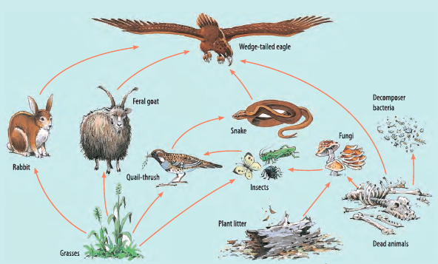

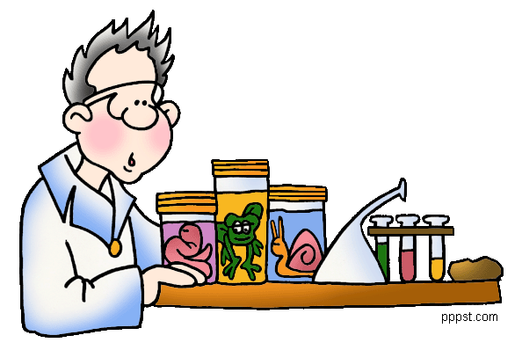
2. Next to each plant and animal write the letter that corresponds to its role in the environment.

P = Producer O = Omnivore H = Herbivore C = Carnivore

For example: Quail thrush C (because a Quail thrush eats insects)
If you like you could colour code the roles also. Producers are green etc.

3. Construct six food chains based on the environment and those plants and animals you have listed. Remember that the arrows show the flow of energy.

Producer Primary Consumer Secondary Consumers
(Herbivore/Omnivore) (Carnivore/Omnivore)

